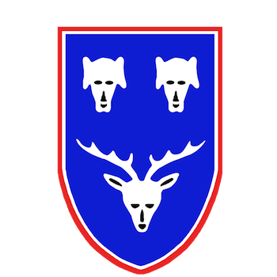
Penicuik Rugby

Youth Permission Form 2019-2020
Player Details
Name:
School Yr.: D.O.B:
Emergency Contact details
Parent/Guardian 1
Name: Relationship to player
Phone numbers:
Parent/Guardian 2
Name: Relationship to player
Phone numbers:
Medical Conditions/Allergies
Please list any relevant medical conditions (e.g. asthma, epilepsy, allergy to penicillin etc.)

Permissions
By ticking the appropriate box(es) and signing this form, I hereby confirm that:
My child may take part in organised rugby activities and/or events with Penicuik Rugby Football Club
My child may be photographed and/or video recorded by authorised individuals during club activities, and those photographs and/or videos may be reproduced or used by Penicuik Rugby Football Club or other authorised persons in an appropriate manner e.g. training purposes, team photos, display purposes on website, noticeboard, open days or fun days
If, during the course of any such rugby activities and/or events, my child – in the opinion of a qualified medical practitioner – requires medical treatment (including inoculations, blood transfusions or surgery) and should no parent or guardian be present to give consent and none be contactable via phone in order to provide consent remotely, then I authorize officials and representatives of Penicuik Rugby Football Club present at the time to consent to such medical treatment to my child as if such consent had been given personally by me
My child’s details may be entered into the Scottish Rugby Union’s player registration database
NOTE: this is an SRU requirement for all youth players
The details I have supplied above may be shared with relevant officials and representatives of Penicuik Rugby Football Club (i.e. coaches and Youth Convenor) in order that they may be available should an emergency arise

Signature of Parent/Guardian
Name (Block Capitals)
Signature: Date:

